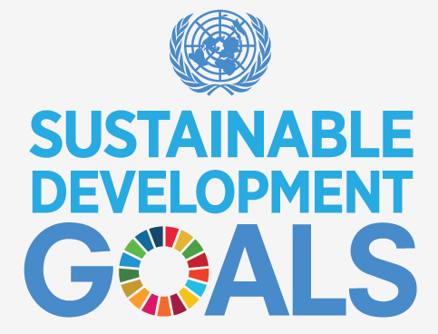

The United Nations Sustainable Development Goal Challenge
Research Planner

Name: _____________________
Subject: ____________________
Teacher: ____________________
Due Date: ___________________

Introduction
This planner is designed to give you a step-by-step guide through the UN Sustainable Development Goals Project which includes a series of online challenges.
The booklet is also supported by an online resource called The United Nations Sustainable Development Goals project website which can be found at http://www.unsdgproject.com/
Each of the Challenges requires you to engage with a series of digital tools while you explore the seventeen Sustainable Development Goals.
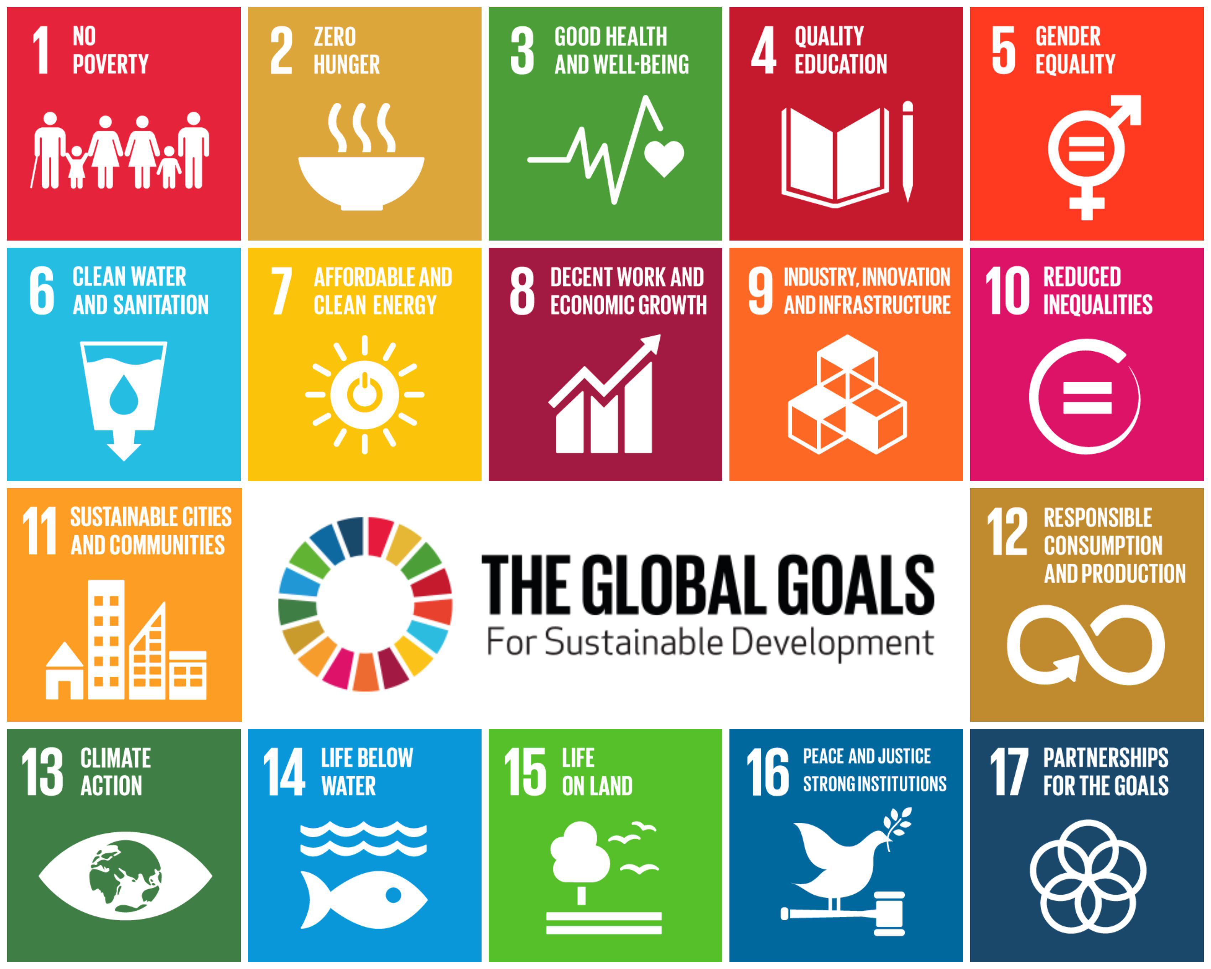
To find out more about the United Nations Sustainable Development Goals visit their official website https://sustainabledevelopment.un.org
The United Nations Sustainable Development Goals Challenges
This project consists of ten Challenges which are listed here.
CHALLENGE ONE
Bulding a website and blog
CHALLENGE TWO
Creating a Home Page for your UN Sustainale Development Goal (UNSDG)
CHALLENGE THREE
Creating a Word Cloud of words that relate to your UNSDG
CHALLENGE FOUR
Selecting and uploading a video to your website
CHALLENGE FIVE
Creating a photo montage for website
CHALLENGE SIX
Creating an interactive map using Thinglink
CHALLENGE SEVEN
Creating an Infographic about your UNSDG.
CHALLENGE EIGHT
Exploring and evaluating programs and charities
CHALLENGE NINE
Exploring innovation and invention realted to your UNSDG.
CHALLENGE TEN
Scenario: If you hade 5 million dollars to suport your goal what would you do and which country would you do it in?
CHALLENGE ONE
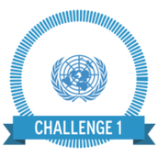
Your first challenge is to build a website and blog or other digital portfolio that you will use to showcase your learning throughout this project.
​The website builder that will be modelled is Weebly (however you may be instructed to use a different platform based on the technology specifications / rules at your school).
Each weekly challenge will require you to add something to your website. ​ This information will help develop a 'picture' of how your knowledge and understanding around your topic is developing as you conduct more research.
When you have completed the creation of your website, you will earn the Website Builder badge.

Write the name of your website here
__________________________________________________________________________________
Write the URL (web address) for your website here
___________________________________________________________________________________
Place a screen capture of your website here.
CHALLENGE TWO
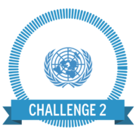
Your second challenge is to create a home page for your website that introduces your chosen United Nations Development Goal. You may have chosen this goal yourself, or it may have been given to you by your teacher.
Your home page should include the following:
- An introduction explaining the UN Development Goals
- An iconic image of your chosen goal
- A brief overview of your chosen goal
- At least 5 facts and figures relevant to your goal
- 5 target goals that you believe to be the most important
- A link to your specific goal on the UN Development Goals page (for example, if your topic is gender equality, provide a link to the gender equality page
A lito

Write a draft for your home pgae before it is placed on your website. Use the space below and have it checked by your teacher before it is placed on the website.
Introduction

Overview

Facts and Figures

Target Goals

Link to the relevant Sustainable Development Goal page

CHALLENGE THREE
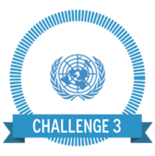
Your third challenge is to create a Word Cloud with at least 30 words that are relevant to your chosen goal. This word cloud will help develop your vocabulary around your topic. Use the UN Development Goal website to help you create your word list. Words may be nouns, verbs or adjectives. Use a word cloud creator like Wordle or Tagxedo.
​Embed your Word Cloud into your blog. Builder badge.

Write your list of words here

Place a copy of your word cloud here

CHALLENGE FOUR
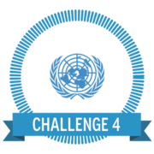
Your fourth challenge is to select and embed a video suited to your UN Development Goal in a blog post.
Step One: Go to the Sustainable Development Goals video page and select your goal.
Step Two: Watch one of the videos
Step Three: Create a blog post called Video Blog Post.
Step Four: Embed the video into your blog post (if you do not know how to do this watch the instructional video on how to embed YouTube videos).
Step Five: In your blog post, write down five things that you have learned about your issue

Write the name of the video you have chosen here

Write the URL (web address for the video)

Make a comment about why you chose this particular video. How does it describe your chosen UNSDG?

CHALLENGE FIVE
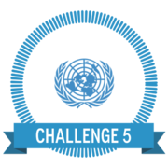
Your fifth challenge is to create a photo montage using the Slideshow or Gallery function in Weebly around your UN Goal (see the example right). Create a new page in your website titled 'Gallery'. Place your montage here.
Your montage must include:
At least 10 images that are 'creative commons' or 'free to use and share' (this means you do not have to get permission to use them)
A variety of aspects relevant to your UN goal (for example, if your UN goal is 'Hunger and food security', don't just get pictures of food - look at farming techniques, food storage, malnutrition etc)
Provide a relevant caption for each image​.

Place a thumbnail of each of your images here. Write the URL for where you obtained each image. Make sure you use Creative Commons or Free to Use or Share images. Your teacher will show you how to locate these images. Place a caption under each image explaining what the image is about.

CHALLENGE SIX
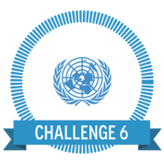
Your sixth challenge is to create an interactive map using Thinglink, highlighting five countries where your UN Goal has the biggest impact. The links you create on your map should provide information about your goals as they relate to that country or link to a relevant website of video. See the example below and others on the Thinglink website for ideas. (www.thinglink.com)
To find an appropriate map to use for the Thinglink activity, try the resources on Studyvibe. Use the video below to show you how to embed your image into your blog page. (www.studyvibe.com.au Password: Vibe16)

Place a copy of your chosen map here with the URL to the relevant page where you have place it on your website.

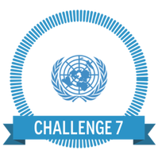
CHALLENGE SEVEN
Your seventh challenge is to create an Infographic about your Sustainable Development Goal. An infographic is an information graphic or poster that contains facts, data and statistics in a visual format. This allows for a lot of information to be presented in a clear and easy fashion. Your infographic should include facts, statistics, images and graphs that relate to your goal. See the example below that was made using an program called easel.ly

Place a copy of your infographic here with the URL to the relevant page where you have placed it on your website

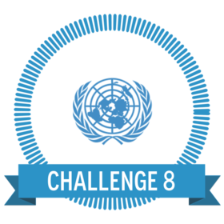
CHALLENGE EIGHT
Your eighth challenge is to explore a range of charities and select two that support your chosen goal. You must complete the Challenge Worksheet.

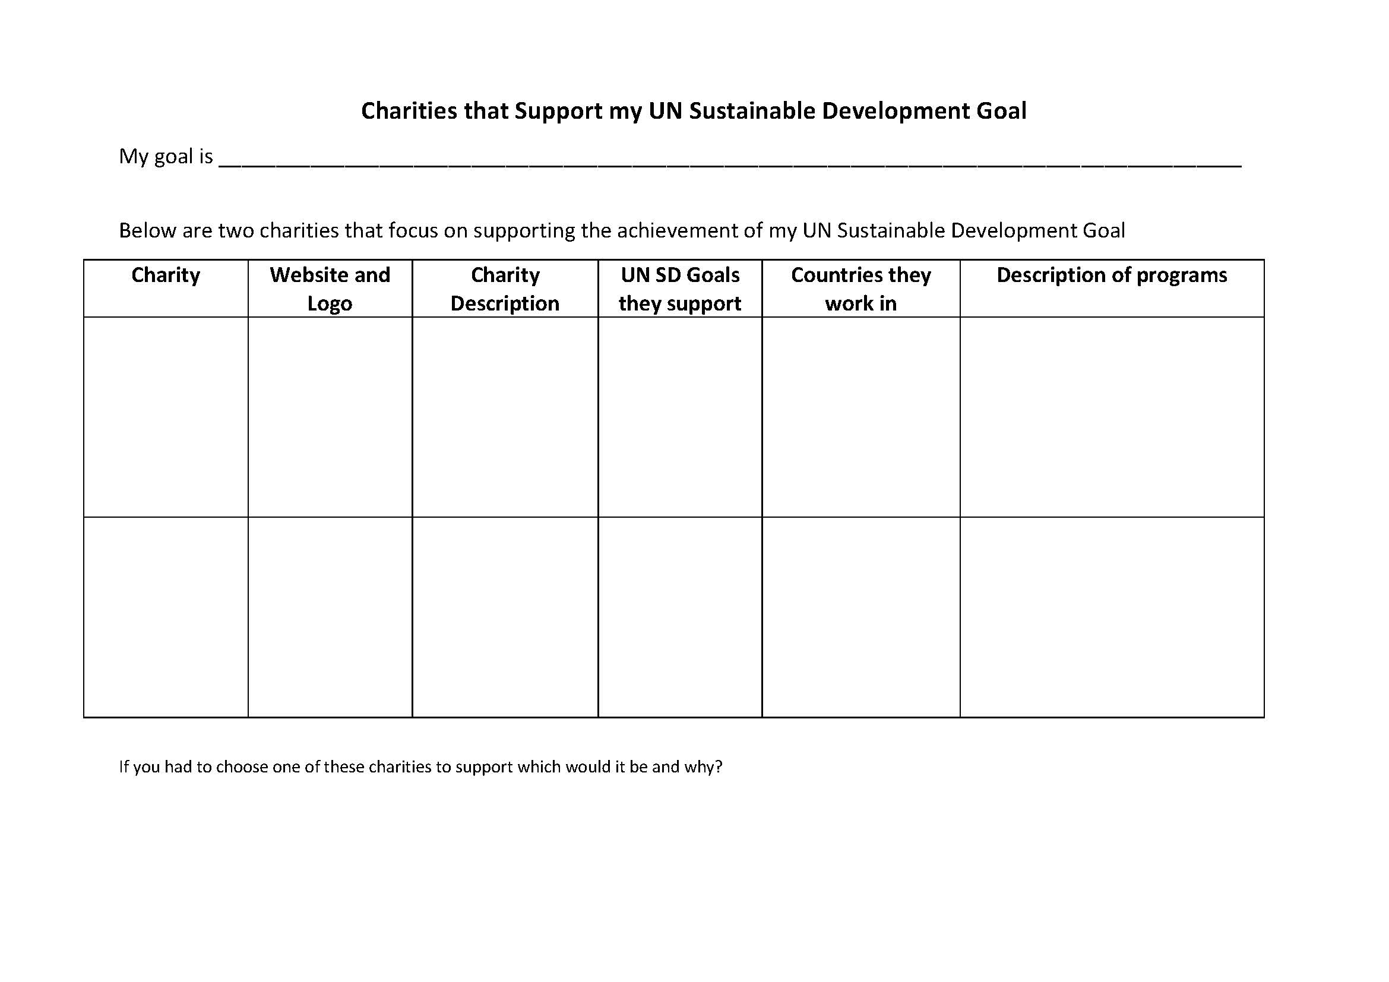
CHALLENGE NINE
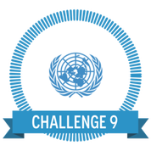
Your ninth challenge is to analyse data around your chosen goal. This will help you identify key information, trends etc around your goal as well as help you determine where you will expend your funds in Challenge Ten.
The websites you will use to access this information can include the following:
- The World Bank (see their topics page)
- UN Data
- Gapminder
- Our World In Data

Identify at leats 10 data sets around your goal. Lsit them here.

Provide a summary of the information you found.

Record the URLs for the sources of information
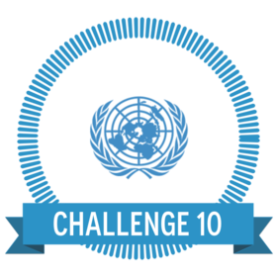
CHALLENGE TEN
Your tenth challenge is to complete the following scenario: If you were given 5 million dollars to support your chosen UN Sustainable Development Goal what would you do and which countries would you select to action this work. Your project can take the form of a formal report, written proposal, boardroom presentation or speech to potential investors.

Provide a brief outline of your project proposal here:
Record of badges received
Please date and sign each badge as they are awarded

Researching your Sustainable Development Goal
The Research Process is a roadmap that can help you make your way through the UNSDG project. There are six stages to this process:
Defining the Task  What is the problem I have to solve? | 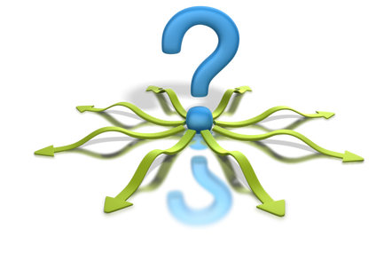 | What are the main ideas or key concepts?  What do I already know about the topic?  What information do I need to find out?  What questions will help guide my research?  What is the best questioning framework to use?  What KEY WORDS will guide my research?
Locating your resources  Where can I find the information I need? |  | Which sources of information are best for my needs?  Which sources do I already have?  Where can I find those resources I don't have?  How can I tell what are reliable sources of information?  What are the best search terms (Key Words) for me to use in my searches?  What are the best databases / search engines for me to use in my search?
Selecting  How will I select the information I need? |  | What structures in the resource can I use to help me find what I am looking for? (Table of Contents, Menu)  What reading techniques will I use to help me select my information? (Skimming, Scanning, SQ3R)  How do I know if this is an authoritative source of information?  How will I know whether this information is recent, relevant, accurate and unbiased?  How will I record the information I find?  How will I cite (credit) my sources? What bibliography format will I use?
Processing and Organising  How can I organise this information so that I can understand it better? |  | How will I organise the information I find?  What is the best way for me to take notes?  Will it help me to use a graphic organiser or mindmap?  How will I combine information from more than one source?  How will I check that I have all the information I need to solve my original problem or answer my research question?
Presenting  How can I best share this information with other people? | 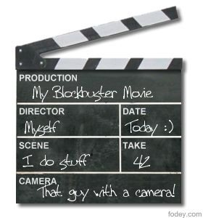 | Who will be my audience?  How will I present my information?  What is the purpose of my presentation?  What is the best format to suit my needs?  Do I need to learn any skills for my chosen presentation format?  How will I demonstrate my understanding?
Evaluating  What have I learned as a result of this process? |  | Did I answer my focus question(s)?  Did I manage my time well?  How will I be assessed?  What did I do well?  What do I need to improve?  How will I apply this knowledge?
SPECIAL NOTE: It is important to realise that this process is not linear. Sometimes you will be doing one or two stages at the same time or you may need to go back to a previous stage if you do not have all of the information you need to complete your task.
Defining the task
Before you start your assignment / research task you need to get very clear about what you are being asked to do.
Unpacking the research task
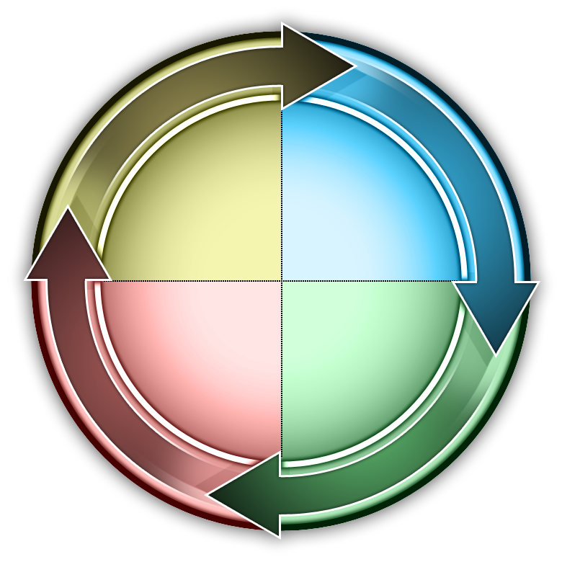Analysing the question / task
Look at the KEY WORDS in your question. Look at the VERBS (or action words) in the task. This will tell you what you have to DO (Example Define, Describe, Compare, Prove)
e.g. Identify and describe 5 challenges that are being faced in the world with regard to your UN Sustainable Development Goal?
Write your research task here…

Underline or highlight the keywords in the task OR write them below.
Topic(s) / Key Words
Verbs (describe, explain, sequence, justify etc.)
Audience (Who is the audience for my task?)

Presentation Format The presentation format for this task has been set in the Challenges
Due Date When is the assignment due? What else is due at the same time? (Make sure you organise your time so that you do not leave the task until the last minute.
Assessment (How am I going to be assessed? Is there an assessment key or rubric?
Expanding your task
There are a number of ways that you can explore your understanding about your topic. You can:
Brainstorm your topic using a graphic organiser such as this explosion chart

OR
You can use a Mindmap
A mindmap lets you ‘rapid fire’ ideas about a topic without putting any judgement on the ideas. Sometimes the ‘way out’ ideas help you to think creatively about your topic. You can create a mindmap on paper or you can use some mindmapping software to help you.
Use this space here to create (or insert) a mindmap)
You can use a number of different Apps to create a mindmap. Check them out here.
Developing your Focus Questions
The type of question you ask will determine the kind of information you look for and find. If you ask a CLOSED question (one that only needs a YES or NO answer you are limiting the information you find. Try to ask OPEN-ENDED questions. Use the Five Ws and H to develop your questions.
Questions starter | Write your questions here
Who?
What?
Where?
When?
Why?
How?
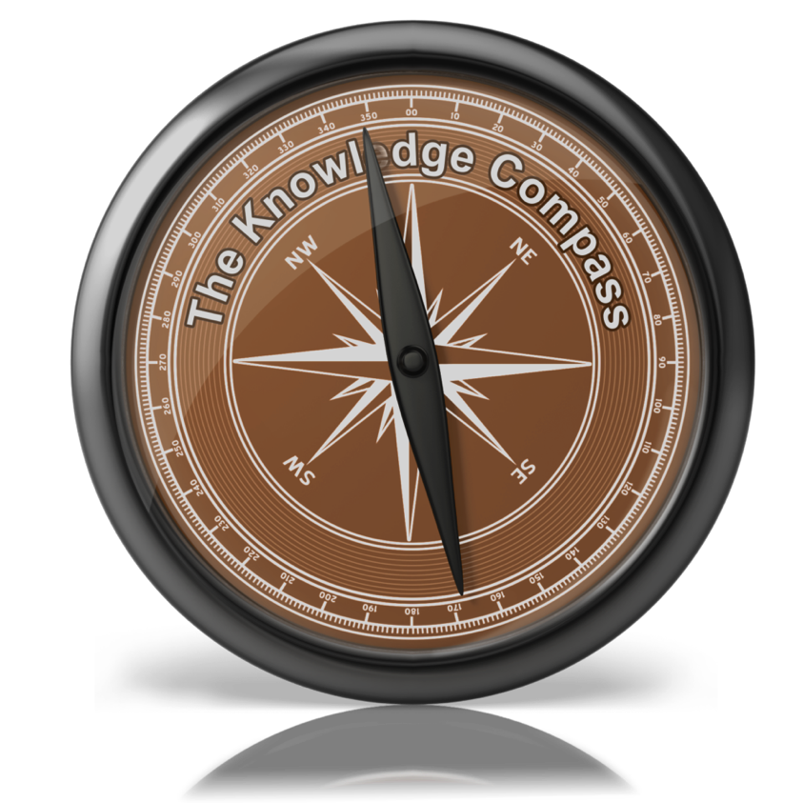 | Use the Knowledge Compass to develop your questions.
Why not use the Thinkers Keys or Six Thinking Hats or Question Matrix to help you write your questions
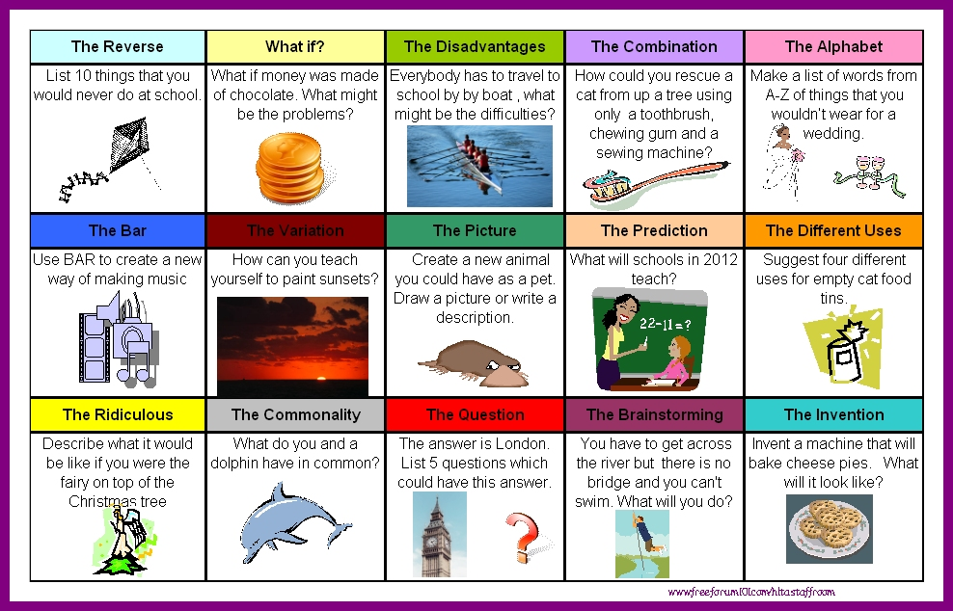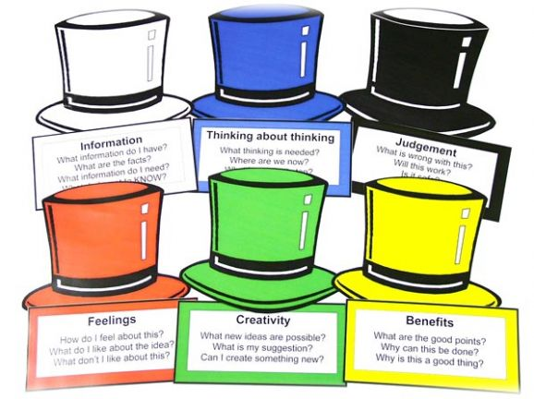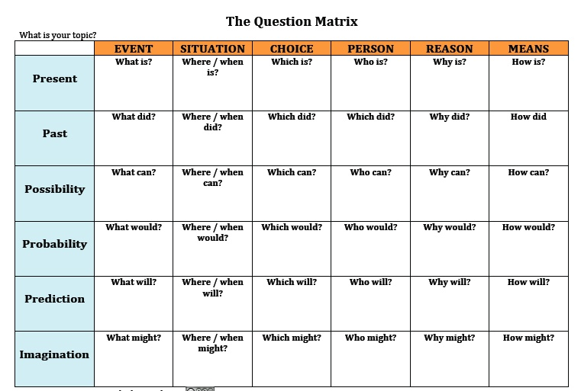
Locating your resources
How do you decide what are the best resources for your research assignment? The type of research task you have will determine the best place to get the information. There are three types of information that you can use:
Primary  This is information that has come directly from the source | Secondary  Someone has written about the topic | Tertiary  These are lists of resources
Interviews  Surveys  Original documents (letters, photographs etc)  Excursions  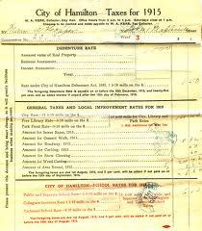  Guest speakers  Realia (real objects) | Books  Encyclopaedias  Newspapers / Periodicals  Journals / Magazines  Blogs /Wikis  Twitter  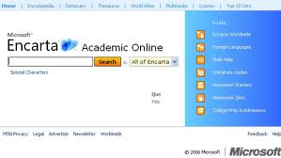  YouTube | Indexes  Directories  Search results (from Google or some other search engine)

Where do I look for the information I need?
The two main places that you will locate resources when you do research at school are:
The Library
The school library has a wide range of traditional and digital resources that have been specifically selected for your educational needs. The three most valuable tools that you can use in the library are:
Library

Internet

Other

Searching the World Wide Web
There are literally ‘millions’ of resources on the internet and that can be a real problem when you are searching for information for your research task. There are some important searching strategies that will help you become a better searcher.
Use these resources on the Research Safari to help you.
How to search effectively online
Going beyond Google and Wikipedia
How to evaluate websites
Search Engines
While many students go straight to Google to do their searching there are many other great search engines that have been developed especially for students.
Instagrok | 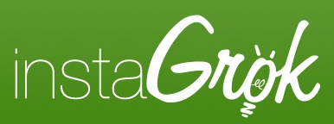 | Mashpedia
Search Cube |  | Sweet Search
Boolify | 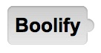 | Wolfram Alpha

Checking the validity of your resources
How do you know what is a ’good source’ of information when you are conducting your research?
Use RADCAB (Created by Karen M. Christensson, M.S. Library Media Education
RELEVANCY Is the information relevant to the question I am trying to answer?
APPROPRIATENESS Is the information suitable to my age and core values?
DETAIL How much information do I need? Is the depth of coverage adequate?
CURRENCY When was the information published or last updated?
AUTHORITY Who is the author of the information?
What are his or her qualifications? Are they an expert in this area? How do you know?
BIAS Why was this information written? Was it written to inform me, persuade me, entertain me, or sell something to me?
Notemaking Outline 1
Task / Problem

Subheading | Notes
Expand this chart as you need to complete your notes.
Notemaking Outline 2
Task / Problem

Heading 1

Subheading a)

Subheading b)

Subheading c)

Heading 2

Subheading a)

Subheading b)

Subheading c)

Heading 3

Subheading a)

Subheading b)

Subheading c)

Heading 4

Subheading a)

Subheading b)

Subheading c)

Research Notes 1
Topic:______________________________________________________________________
Focus Question:______________________________________________________________

Research Notes 2
Topic:______________________________________________________________________
Focus Question:______________________________________________________________

Graphic Organisers
Using Graphic Organisers to write your notes
Sometimes using a structured note making sheet called a “Graphic Organiser” can help you organise your information as you do your research. This will help you at the stage where you need to write your report or develop your presentation. Here are some graphic organisers that you may find useful.
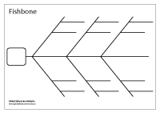 | 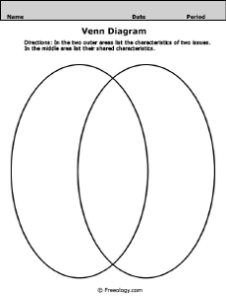 | 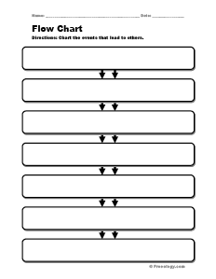 | 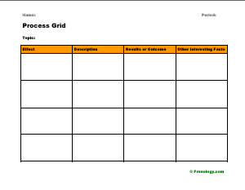
Fishbone Diagram | Venn Diagram | Flow Chart | Matrix
 | 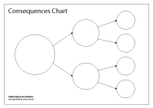 | 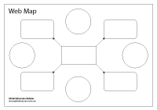 | 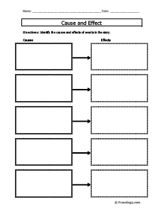
T Chart | Consequence Chart | Web Map | Cause / Effect
There are many other graphic organisers that you can use to organise your information as you do your research. Follow this link to Research Safari to download copies of the organisers and look for others.

Presenting your work
The presentation format you use will greatly depend on the purpose and audience for your tasks. Listed below are a range of presentation and digital storytelling tools that you may consider using for your final product. The required formats you will be using for this assignment have been highlighted. If you use any others please mark them as required.

Slideshow Presentation | Brochure | Word Cloud | Digital Story
Interactive map | Blog | Website | Journal / Diary
Infographic | Photo Montage | Cartoon / Animation | Video

Evaluating your work
The evaluation stage is perhaps one of the most important stages of any research task. Not only does it give you a chance to see how well you did in the task but it also helps you to identify the areas you may need to work on in the future. Your digital badges will give you a visual representation of your achievement and if online will link to the evidence of achievement for each Challenge.
In terms of your own personal reflection about this project some of the questions you would ask yourself are:
How did I go?

What did I do well?

What did I struggle with?

What do I need to improve next time?

What are five key things I learned from this task?
1)

2)

3)

4)

5)

How will this learning make a difference time?

What is one skill I need to work on for my next assignment?

How else could I have done this task?

Add any other information you may need for your assignment here.

END

