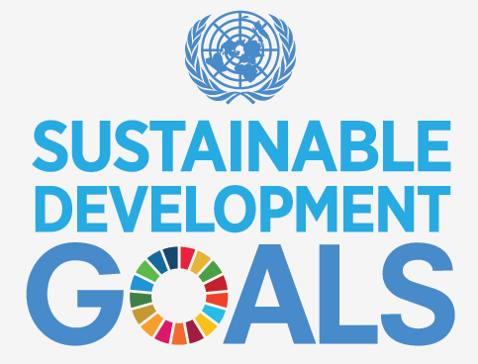

The United Nations Sustainable Development Goal Challenge
Project Planning Guide

Name: _____________________
Subject: ____________________
Teacher: ____________________
Due Date: ___________________

Introduction
Challenge Ten is designed to amalgamate all of the information you have collected through the other challenges to create a project that could realistically be implemented to address your chosen goal. The scenario is:
If you were given five million dollars to help achieve one of the UN development goals what would you do? In which country would you do it? and Why in that country?
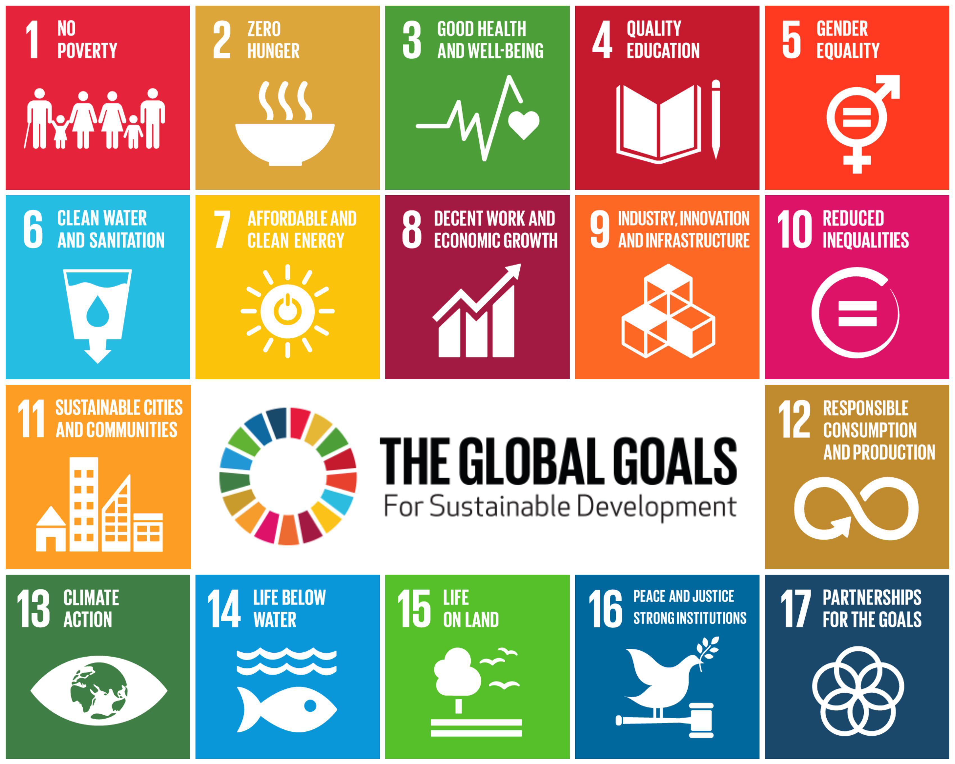
To find out more about the United Nations Sustainable Development Goals visit their official website https://sustainabledevelopment.un.org

The Goal I have chosen to focus on is:

The country I have chosen in which to action my project is:

The reason I have chosen this country is:
HINT: You will need to provide statistical evidence for your chosen country (e.g. this country has the greatest rate of infant mortality or lowest rate or females in schools)

The projects (s) / initiatives I have chosen to spend my money on are:
List here the various initiatives you have chosen to undertake. You may choose more than one. Try to make them complementary so they support each other. You may use other initiatives as a model (e.g. Caritas programs)

The reasons for these choices are:
Give the reasons why you have chosen these particular programs. (They may have already been successful elsewhere - provide evidence of how they have helped support the goal). You may be creating a completely new initiative that no-one else has tried.

My predicted outcome for these projects is that…..
List your intended goals for the project – reduces infant mortality, more girls attending schools, less pollution in a particular area due to recycling project etc.)

The evidence I have that this is a likely outcome are
Use examples of where other similar initiatives have been successful.

FORCE FIELD ANALYSIS
A Force Filed Analysis allows you to think about the things that will potentially help of hinder your project. The better prepared you are for these eventualities the more likely your chance of dealing with the blockers and using the enablers to help you achieve your goal.
ENABLERS:
The things that are going to help me achieve my goals are:
List here the things that you think will be able to help you with your project. It may be other associations or programs, the government in the country you are working, the people in the community you will work in etc.

BLOCKERS:
The things that may get in the way of me achieving my goal are:
List here the things that you think will get in the way of you trying to implement your project. It may be the government in the country; it could be it is a war zone so difficult to get in supplies; it could be that people in the village are illiterate and very afraid of foreigners. Try to think laterally (outside the box) about these possibilities.

EXPENDITURE BREAKDOWN:
Break down the way you will expend your money. Suggestion: Place it is a table or spreadsheet that itemises the various categories.

I will get help from the following places

The time frame for my project is

I will know I have achieved my goal when:

